**A Project Report**

**On**

**SPACE AND TECHNOLOGY E-LEARNING**



Submitted in partial fulfilment of the

requirements for the award of the degree

of

**MASTER OF COMPUTER APPLICATIONS**

**SUBMITTED BY**

**MEESALA VEERA VENKATA HARIKA**

**(22P31F00035)**

**Under the Esteemed Guidance of**

**Ms.Mohammad.Gousia, MCA**

**Assistant Professor**



**DEPARTMENT OF MCA**

**ADITYA COLLEGE OF ENGINEERING AND TECHNOLOGY**

(Approved by AICTE, Affiliated to JNTUK & Accredited by NBA, NAAC with ‘A+’Grade)

Recognized by UGC under the sections 2(f) and 12(B) of the UGC act 1956 SURAMPALEM-533437, East Godavari District, ANDHRA PRADESH.

2022-2024

**ADITYA COLLEGE OF ENGINEERING AND TECHNOLOGY**

(Approved by AICTE, Affiliated to JNTUK & Accredited by NBA, NAAC with ‘A+’Grade) Recognized by UGC under the sections 2(f) and 12(B) of the UGC act 1956 SURAMPALEM-533437, E.G.Dist, ANDHRA PRADESH.

2022-2024

**DEPARTMENT OF MCA**



**CERTIFICATE**

This is to certify that the project work entitled, **“SPACE AND TECHNOLOGY E-LEARNING”,** is a Bonafede work carried out by **MEESALA VEERA VENKATA HARIKA** bearing Regd.No:**22P31F0035** submitted to the requirements for the award of th**e** Computer Applications in partial fulfilment of the requirements for the award of degree of **MASTER OF COMPUTER APPLICATIONS** from **Aditya College of Engineering and Technology,** Surampalem during the academic year **2023-2024.**

**Project Guide**

**Head of the Department**

**Ms.Mohammad.Gousia, MCA**

**Mr.R.V.V.N.BheemaRao, M.Tech(Ph.D)**

Assistant Professor,

Associate Professor,

Department of MCA,

Department of MCA,

Aditya College of Engg & Tech,

Aditya College of Engg & Tech,

Surampalem-533437.

Surampalem-533437.

**External Examiner**

**DECLARATION**

I hereby declare that the project entitled **“SPACE AND TECHNOLOGY E-LEARNING”** done on my own and submitted to **Aditya College of Engineering & Technology, Surampalem** has been carried out by me alone under the guidance of **Ms.Mohammad.Gousia.**

Place: Surampalem

Date:

**(M.V.V.HARIKA)**

**22P31F00035**

**ACKNOWLEDGEMENT**

The satisfaction and euphoria that accompany the successful completion of any task would be incomplete without the mention of the people who made it possible, whose constant guidance and encouragement crowned our efforts with success. It is a pleasant aspect that I have now the opportunity to express my gratitude for all of them.

The first person I would like to thank is my guide **Ms.Mohammad.Gousia, MCA, Assistant Professor, Aditya College Of Engineering And Technology, Surampalem,** Herwide knowledge and logical way of thinking have made a deep impression on me. Her understanding, encouragement, and personal guidance have provided the basis for this project. She is a source of inspiration for innovative ideas and his kind support is well known to all her students and colleagues.

I wish to thank **Mr.R.V.V.N.Bheemarao, M.Tech, Head of the Department, Aditya College Of Engineering And Technology, Surampalem,** has extended his support for thesuccess of this project.

I also wish to thank **Dr.D.Sanjay, Principal, Aditya College Of Engineering And Technology, Surampalem,** who has extended his support for the success of this project.

I would like to thank all the **Management & Technical Supporting Staff** for their timely help throughout the project.

**ABSTRACT**

**ABSTRACT**

The project envisions the creation of a dedicated website that illuminates the profound intersection between Master of Computer Applications (MCA) subjects and their real-world application in the field of space exploration, By unraveling the symbiotic relationship between computational technologies and space missions, the website aims to inspire curiosity, promote interdisciplinary collaboration, and showcase the pivotal role of MCA knowledge in advancing space exploration endeavors.

In these the key components of my website are, Technology Spotlights, Responsive Design and Accessibility, User-Generated Content and Community Interaction, Educational Resources, Multimedia Content, Interactive Timeline. By synthesizing these elements, the proposed website seeks to establish a bridge between academic research and the cosmos, fostering a greater appreciation for the transformative impact of academic technologies in advancing the frontiers of space exploration. This project not only aims to celebrate past achievements but also to inspire future collaborations and innovations at the intersection of academia and the cosmos. Developing a website that showcases the application of MCA (Master of Computer Applications) technologies in space exploration would involve a combination of frontend and backend technologies. For Frontend Development I used HTML/CSS for structuring and styling the website’s content and Javascript to create interactive and dynamic content in the website, and for Backend Development I used Django framework and MySql database. As technology continues to advance, this website stands as a testament to the symbiotic relationship between academic knowledge and real-world applications.

**LIST OF CONTENTS**

**PAGE NO**

**Chapter 1: Introduction**

|  |  |  |
| --- | --- | --- |
| 1.1 | Brief Introduction of The Project | 02 |
| 1.2 | Motivation of The Project | 02 |
| 1.3 | Objective of The Project | 02 |
| 1.4 | Organization of The Project | 03 |
| **Chapter 2: System Analysis** | |  |
| 2.1 | Existing System | 05 |
| 2.2 Proposed System | | 05 |
| 2.3 | Feasibility Study | 05 |
| 2.4 | Functional Requirements | 06 |
| 2.5 | Non-Functional Requirements | 07 |
| 2.6 | Software And Hardware Requirements | 07 |
| **Chapter 3 : System Design** | |  |
| 3.1 Introduction | | 09 |
| 3.2 Data Dictionary | | 09 |
| 3.3 Data Flow Diagram | | 09 |
| 3.4 UML Diagram | | 12 |
| 3.4.1 Use Case Diagram | | 13 |
| 3.4.2 Class Diagram | | 14 |

|  |  |
| --- | --- |
| **Chapter 4: Technology Description** | 16 |
| **Chapter 5: Sample code** | 20 |
| **Chapter 6: Testing** | 31 |
| **Chapter 7: Screen Shots** | 36 |
| **Conclusion** | 45 |
| **Bibliography** | 46 |

**LIST OF FIGURES**

|  |  |  |  |
| --- | --- | --- | --- |
| **S.NO** | **Figure No** | **Name Of The Figure** | **Page No** |
|  |  |  |  |
| 01 | 3.3.1 | Data Flow Diagram | 10 |
|  |  |  |  |
| 02 | 3.3.2 | Context Diagram (Level 1) | 11 |
|  |  |  |  |
| 03 | 3.3.3 | Data Flow Diagram For Guest (Level 2) | 12 |
|  |  |  |  |
| 04 | 3.4.1 | Use Case Diagram | 13 |
|  |  |  |  |
| 05 | 3.4.2 | Class Diagram | 14 |
|  |  |  |  |
| 06 | 3.4.3 | ER Diagram | 15 |
|  |  |  |  |

**LIST OF SCREEN SHOTS**

|  |  |  |  |
| --- | --- | --- | --- |
| **S.NO** | **Screen No** | **Name of the Screen** | **Page No** |
|  |  |  |  |
| 01 | 7.1 | Home Page | 37 |
|  |  |  |  |
| 02 | 7.2 | Registration Page | 38 |
|  |  |  |  |
| 03 | 7.3 | Login Page | 39 |
|  |  |  |  |
| 04 | 7.4 | Lets learn Page | 40 |
|  |  |  |  |
| 05 | 7.5 | News Page | 41 |
|  |  |  |  |
| 06 | 7.6 | E-books page | 42 |
|  |  |  |  |

**CHAPTER-1**

**INTRODUCTION**

**1.INTRODUCTION**

The This project involves the development of a dedicated website with a primary focus on showcasing the practical applications of Master of Computer Applications (MCA) technologies within the realm of space exploration. The central objective is to bridge the gap between theoretical knowledge obtained through MCA subjects, including algorithms, artificial intelligence, data structures, and software engineering, and their tangible implementations in real-world space missions. Through a series of technology showcases, the website aims to highlight and elucidate the significant contributions of MCA subjects to the advancement of space exploration.To provide users with a more immersive experience, the project includes the integration of interactive simulations using advanced technologies such as Three.js or Babylon.js. These simulations aim to offer a hands-on understanding of how MCA principles are applied in the context of space-related scenarios, fostering a deeper appreciation for the role of computational technologies in solving complex challenges inherent to space exploration. To provide users with a more immersive experience, the project includes the integration of interactive simulations using advanced technologies such as Three.js or Babylon.js.

**1.1 Brief Introduction Of The Project:**

The project incorporates community interaction features such as discussion forums and social media integration. This collaborative aspect aims to create a vibrant community where individuals passionate about the convergence of MCA and space exploration can engage in discussions, share knowledge, and build connections. Through this, the project endeavors to foster a sense of community and encourage ongoing dialogue among users. Ensuring a user-friendly experience across various devices, implementing responsive design principles, and incorporating security measures, including SSL certificates and secure authentication mechanisms, are fundamental aspects of the project. These considerations are crucial for providing a seamless and secure environment for users exploring the website's content. Lastly, the project integrates analytical tools such as Google Analytics or Matomo to track user behavior and gather insights into website performance. This data-driven approach allows for continuous refinement and optimization, ensuring that the website remains a dynamic and relevant resource in the ever-evolving landscape of MCA technologies and space exploration.

In addition to showcasing technological applications, the website will serve as an educational hub, offering a curated collection of resources, tutorials, and code examples. This repository is designed to support the learning and skill development of individuals interested in the practical aspects of MCA subjects relevant to space technology.

**1.2 Motivation Of The Project:**

Bridging Theory and Practice: The project is motivated by the desire to bridge the gap between theoretical knowledge gained through MCA subjects and its practical applications. By showcasing how MCA technologies are employed in real-world space missions, the project aims to make academic concepts more tangible and relevant.

**1.3 Objective Of The Project:**

The objective of the project is to develop a comprehensive website that highlights and explores the practical applications of Master of Computer Applications (MCA) technologies in the context of space exploration.

By featuring interviews with space professionals, the project aims to humanize technology and showcase the impact of MCA knowledge in the space industry. These personal narratives provide insight into the real-world challenges and successes, offering motivation for individuals pursuing careers at the intersection of computing and space exploration. The project aims to achieve the following objectives:

* This website Provide detailed showcases of specific MCA subjects, such as algorithms, artificial intelligence, data structures, and software engineering.
* This website illustrates how these subjects are applied in solving real-world challenges encountered in space missions computers.
* The space and technology website Integrate discussion forums and social media features to foster a community of learners, educators, and professionals.
* The project on space technology Motivate and inspire students and professionals by showcasing the transformative impact of MCA technologies in pushing the boundaries of space exploration.

**1.4 Organization of the Project:**

* **System Analysis:** The description of the current system, the planned system, and the required specifications make up the majority of this chapter.
* **System Design:** This chapter is consisting of modules description and algorithms with example and use case diagrams, class diagrams, sequence diagrams, Collaboration diagrams and activity diagrams.
* **Technology Description:** This chapter mainly consists of the technology description of this project.
* **Sample Code:** This chapter consisting of sample code for the few modules.
* **Testing:** This chapter is mainly consisting of testing techniques and test cases for modules.
* **Screen Shots:** This chapter is mainly consisting of output screens of this project.
* **Conclusion:** Main Conclusion of the project is to segmenting the customers based on characteristics.

**CHAPTER-2**

**SYSTEM ANALYSIS**

**2. SYSTEM ANALYSIS**

**2.1 Existing System**

The current landscape of space and technology e-learning systems reflects a dynamic intersection between education and the rapidly evolving realms of space exploration and technological innovation. the current state of space and technology e-learning is characterized by a delicate balance between innovation and overcoming inherent limitations. In examining the strengths and drawbacks of these systems, we gain insights into the ongoing efforts to enhance the effectiveness of online education in these dynamic and complex domains.

**Disadvantages**

* The quality of online instruction may vary, and some learners may miss out on valuable insights and mentorship.
* Limited access to high-end laboratories and equipment can impact the depth of learning and practical exposure.
* Inadequate attention to inclusivity may result in certain groups being excluded from educational opportunities.
* My website lack of hands-on experience that can hinder the development of practical skills and problem-solving abilities.

**2.2 Proposed System**

The proposed system for showcasing the application of Master of Computer Applications (MCA) technologies in space exploration involves the development of a comprehensive website. This platform aims to bridge the gap between academic knowledge and real-world applications, providing an engaging and informative space for students, professionals, and enthusiasts.

**Advantages**

* It Provides a rich and immersive learning experience for students and enthusiasts interested in MCA technologies and their practical applications in space exploration.
* It Features interviews with professionals working at the intersection of MCA and space exploration.
* It Fosters a sense of community through discussion forums and social media integration.

**2.3 Feasibility Study**

A Feasibility study evaluates the project’s potential for success; therefore, perceived objectivity is an important factor in the credibility of the study for potential investors and lending institutions. It must therefore, be conducted with an objective, unbiased approach to provide information upon which decisions can be based. Here, we discuss 3 major feasibility studies required for our project.

* Economic Feasibility
* Technical Feasibility
* Operational Feasibility

**ECONOMIC FEASIBILITY**

Evaluating the economic feasibility of space and technology e-learning initiatives requires a comprehensive analysis of various factors. Firstly, the cost of development and implementation plays a pivotal role, encompassing expenses related to platform creation, content development, and infrastructure setup. Managing ongoing operational costs, such as maintenance and updates, is crucial to sustaining the initiative in the long run. Moreover, the economic accessibility of the e-learning system for learners is vital. If the costs of courses or required technologies are prohibitively high, it may hinder widespread participation, impacting the success of the program.

**TECHNICAL FEASIBILITY**

Technical feasibility is carried out to determine whether the project is feasible in terms of software, hardware, personnel, and expertise, to handle the completion of the project. It considers determining resources for the proposed system. As the system is developed using python, it is platform independent. Therefore, the users of the system can have average processing capabilities, running on any platform. The technology is one of the latest hence the system is also technically feasible.

**OPERATIONAL FEASIBILITY**

Operational feasibility is the measure of how well a proposed system solves the problems with the users. Operational feasibility is dependent on human resources available for the project and involves projecting whether the system will be used if it is developed and implemented. The project is operationally feasible for the users as nowadays almost all the humans are familiar with digital technology.

**2.4 Functional Requirements**

System Functional requirements outline the specific features and capabilities that the proposed system must have to fulfill its intended purpose. Here are functional requirements for the system showcasing the application of Master of Computer Applications (MCA) technologies in space exploration:

* Feature interviews with professionals and embed video content.
* The system implement a search feature for users to quickly find relevant content.
* The system should be scalable to handle large datasets and multiple users, and compatible with different hardware and software platforms.

**2.5 Non Functional Requirements**

The following are the non-functional requirements for the space and technology e-learning website.

* Handle a large number of concurrent users, ensuring optimal performance during peak times.
* Implement encryption, authentication, and authorization mechanisms to protect against unauthorized access.
* High availability is crucial to ensure users can access educational resources whenever needed.

**2.6 Software and Hardware requirements**

**SOFTWARE REQUIREMENTS**

|  |  |  |  |
| --- | --- | --- | --- |
| • | **Operating System :** | | Windows 10 |
| • | **Backend** | **:** | Python |
| • | **Framework** | **:** | Django |
| • | **Frontend** | **:** | HTML, CSS |

**HARDWARE REQUIREMENTS**

|  |  |  |  |
| --- | --- | --- | --- |
| • | **Processor** | **:** | Intel Core i5 |
| • | **Speed** | **:** | 2.2 Ghz |
| • | **RAM** | **:** | 8GB |
| • | **Hard Disk** | **:** | 500GB |

**CHAPTER-3**

**SYSTEM DESIGN**

**3.SYSTEM DESIGN**

**3.1 Introduction**

The system design for the space and technology e-learning platform involves a meticulous planning process to establish the blueprint for the entire system. At its core, the architecture design sets the foundation by defining the structural framework and organization, guiding decisions on component distribution and interactions. A key focus is placed on creating a user interface that not only caters to the educational content but is also intuitive and user-friendly. This involves incorporating principles of user experience, responsive design, and accessibility standards to ensure a seamless and inclusive learning environment across diverse devices and user needs. Additionally, the system design addresses the intricate details of how different modules, components, and interfaces will function cohesively to achieve the overarching objectives of the platform.

**3.2 Data Dictionary**

A data dictionary is a structured description of data elements within a system or database, providing details about the data, its format, and its relationships. In the context of space and technology, a data dictionary could be developed to document various aspects of space missions, satellite systems, technology projects, or any other related dataset.

**3.3 Data Flow Diagram**

Data Flow Diagrams (DFDs) are graphical representations of how data moves within a system. In the context of space and technology, a DFD could illustrate the flow of data within a space mission control system, a satellite communication network, or any other technological process. Below are examples of potential data flow diagrams for different scenarios:

The main notations we widely used for the Data flow diagrams are mentioned below and these are and various elements can be drawn by using of those.



**process**

**external entity**

**System data**



**Data flow**

**Data store**

**Data Flow Diagram**

**Level-0**

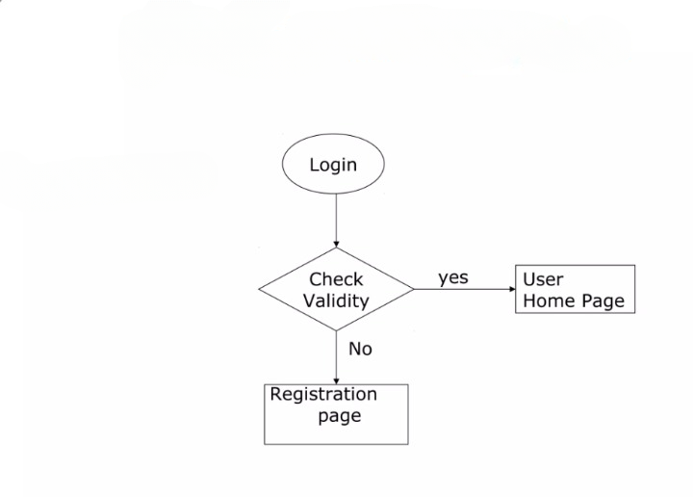

**LEVEL-1**

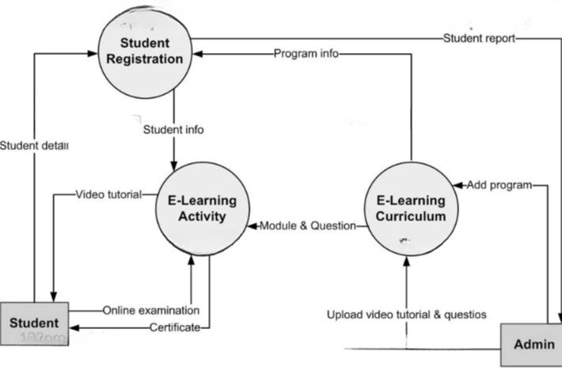

**LEVEL-2**

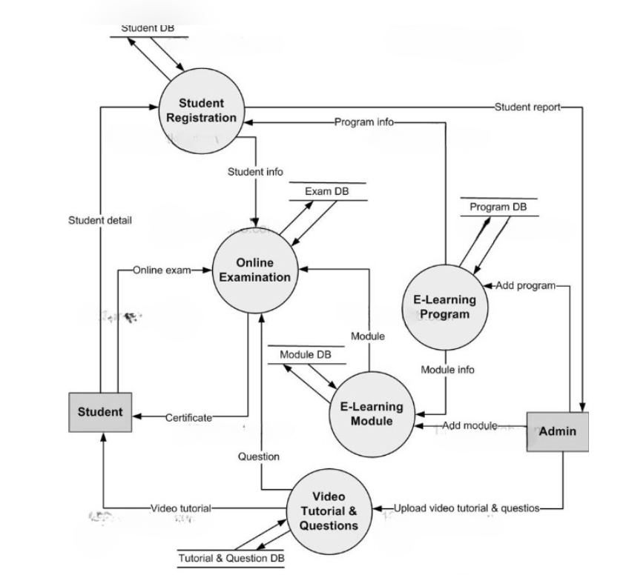

**3.4 UML Diagrams**

The unified modelling language allows the software engineer to express an analysis model using the modelling notation that is governed by a set of syntactic semantic and pragmatic rules. A UML system is represented using five different views that describe the system from distinctly different perspective. UML is specifically constructed through two different domains UML Analysis modelling, this focuses on the user model and structural model views of the system UML design modelling, which focuses on the behavioural modelling, implementation modelling and environmental model views. These are divided into the following types.

• Use case Diagram

• Class Diagram

**3.4.1 Use case Diagram**

Use Case diagrams identify the functionality provided by the system (use cases), the users who interact with the system (actors), and the association between the users and the functionality. Use Cases are used in the Analysis phase of software development to articulate the high-level requirements of the system. The primary goals of Use Case diagrams include:

* Providing a high level view of what the system does.
* Identifying the users (“actors”) of the system. • Determining the areas needed human-computer interfaces.

**USE CASE DIAGRAM**

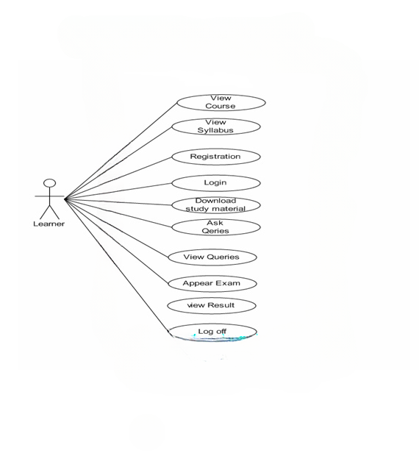

**3.4.2 Class Diagram**

Class diagrams identify the class structure of a system, including the properties and methods of each class. Also depicted are the various relationships that can exist between classes, such as an inheritance relationship. Part of the popularity of Class diagrams stems from the fact that many CASE tools, such as Rational XDE, will autogenerate code in a variety of languages, these tools can synchronize models and code, reducing the workload, and can also generate Class diagrams from object-oriented code.

**CLASS DIAGRAM**

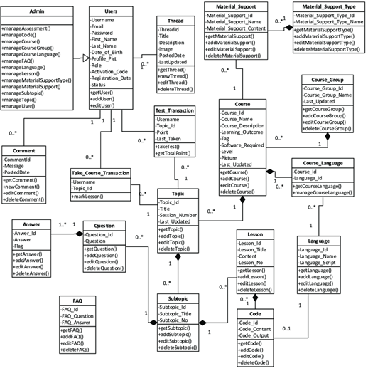

**3.4.3 ER DIAGRAM**

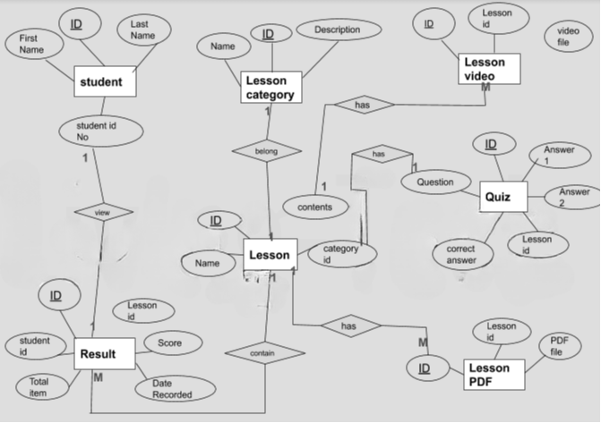

**CHAPTER-4**

**TECHNOLOGY DESCRIPION**

**4. TECHNOLOGY DESCRIPTION**

**4.1 Introduction to Python:**

Python is a versatile and high-level programming language known for its readability and simplicity. Created by Guido van Rossum and first released in 1991, Python has since become one of the most popular and widely used languages in the world of software development. Its design philosophy emphasizes code readability, allowing developers to express concepts in fewer lines of code than might be possible in other languages, making it an ideal language for beginners and experienced programmers alike. One of Python's key strengths lies in its extensive standard library, providing modules and packages that facilitate a wide range of tasks. Whether you're working on web development, data analysis, artificial intelligence, or scientific computing, Python's rich ecosystem of libraries contributes to its flexibility and efficiency. Some well-known libraries, such as NumPy, Pandas, and TensorFlow, have solidified Python's position as a go-to language for data science and machine learning. Python's syntax is straightforward and emphasizes the use of indentation to define code blocks, promoting clean and readable code. It supports both procedural and object-oriented programming paradigms, making it adaptable to various project requirements. Additionally, Python has a large and active community, contributing to its continuous development and ensuring the availability of extensive resources, documentation, and support. Whether you're a beginner learning your first programming language or an experienced developer exploring new technologies, Python's simplicity, versatility, and community support make it an excellent choice for a wide array of applications. Its user-friendly design and robust capabilities have propelled it to the forefront of the programming landscape, where it continues to play a central role in shaping the future of software development

* Python can be used on a server to create web applications.
* Python can be used alongside software to create workflows.
* Python can connect to database systems. It can also read and modify files.
* Python can be used to handle big data and perform complex mathematics.
* Python can be used for rapid prototyping, or for production-ready software development.

One unusual Python feature is that the whitespace indentation of a piece of code affects its meaning. A logical block of statements such as the ones that make up a function should all have the same indentation, set in from the indentation of their parent function or "if" or whatever. If one of the lines in a group has a different indentation, it is flagged as a syntax error. Python's use of whitespace feels a little strange at first, but it's logical and I found I got used to it very quickly. Avoid using TABs as they greatly complicate the indentation scheme (not to mention TABs may mean different things on different platforms). Set your editor to insert spaces instead of TABs for Python code.

**4.2 Introduction to Django**

Django is a high-level, open-source web framework for the Python programming language. It follows the Model-View-Controller (MVC) architectural pattern, but in Django, it's often referred to as the Model-View-Template (MVT) pattern. Developed and maintained by the Django Software Foundation (DSF), Django provides a set of tools and conventions to help developers build web applications quickly and efficiently.

**Models**:

Models represent the data structure of your application. Django uses an Object-Relational Mapping (ORM) system, allowing you to define your data models in Python code. These models are then translated into database tables.

**Views:**

Views handle the logic of your application. A view receives a web request, processes it, and returns a web response. Views can be simple functions or more complex classes, and they interact with models to retrieve or modify data.

**Templates**:

Templates are used to define the presentation layer of your application. They are HTML files with embedded Django template language, allowing you to dynamically generate content based on data from your views.

**URLs and Routing**:

Django uses a URL dispatcher to map URLs to views. You define URL patterns in a central configuration file, and Django uses this to direct incoming requests to the appropriate view.

**Admin Interface:**

Django comes with a built-in admin interface that allows developers and administrators to manage the application's data through a web-based UI. This is especially useful during development and for basic data management tasks.

**Middleware:**

Middleware components are used to process requests and responses globally before they reach the view or after they leave the view. Middleware can perform tasks such as authentication, security, and request/response modification.

**Forms:**

Django provides a forms library for handling HTML forms. Forms simplify the process of collecting and validating user input.

**4.3 Introduction to HTML:**

HTML, which stands for HyperText Markup Language, is the standard markup language for creating and structuring web pages. It is the backbone of web content and provides a way to define the structure and elements of a document. HTML consists of a series of elements, each represented by a tag, that enclose or wrap around different parts of the content to give it meaning and structure.

**Key points about HTML include:**

**Markup Language:**

HTML is a markup language, not a programming language. It uses tags to annotate elements within a document, indicating how those elements should be displayed or behave**.**

**Document Structure:**

HTML documents are hierarchical and have a tree-like structure. Elements can be nested within each other, creating a clear hierarchy that represents the relationships between different parts of the content**.**

**Tags:**

Tags are the building blocks of HTML. They are enclosed in angle brackets (< >) and come in pairs: an opening tag and a closing tag. The closing tag has a forward slash (/) before the tag name. For example**:**

html

Copy code

<p>This is a paragraph.</p>

**Elements:**

An element is the combination of an opening tag, content, and a closing tag. Elements can be as simple as a single word or as complex as a nested structure of various elements. Example**:**

html

Copy code

<h1>This is a heading</h1>

**Attributes:**

Tags can have attributes, which provide additional information about the element. Attributes are usually included in the opening tag and come in name-value pairs. Example**:**

html

Copy code

<a href="https://www.example.com">Visit Example</a>

HTML5 introduced a set of semantic elements that provide additional meaning to the structure of a page. Examples include <header>, <nav>, <article>, <footer>, and more.

Links and References:

HTML allows you to create hyperlinks to link to other pages or resources, as well as embed images, videos, and other media.HTML provides tags for creating ordered and unordered lists (<ol>, <ul>) and tables (<table>, <tr>, <td>), enabling the organization of content in a structured manner. HTML works in conjunction with CSS (Cascading Style Sheets) and JavaScript to create dynamic, visually appealing, and interactive web pages. It serves as the foundation for web development and is supported by all modern web browsers**.**

**4.3 Introduction to CSS:**

CSS, which stands for Cascading Style Sheets, is a style sheet language used to describe the presentation of a document written in HTML or XML. In simpler terms, it is a technology used for styling web pages and defining how web documents should be presented on different devices.

**Key points about CSS include:**

**Style Definition:**

CSS defines how HTML elements should be displayed. It can control the layout, colors, fonts, and other visual aspects of a web page.

**Separation of Concerns:**

CSS allows for the separation of content (HTML) and presentation (CSS). This separation makes it easier to maintain and update websites. Changes to the style do not affect the content, and vice versa.

**Selectors and Declarations:**

CSS uses selectors to target HTML elements and declarations to define the styles. A declaration consists of a property and a value. For example:

**css**

Copy code

/* Selector: All paragraphs */

p {

/* Declaration: Set text color to blue */

color: blue;

}

**Cascading:**

The term "cascading" in CSS refers to the order of priority in applying styles. Styles can be inherited from parent elements, overridden by more specific selectors, and influenced by external style sheets.

**Box Model:**

CSS treats each HTML element as a box model, comprising content, padding, border, and margin. Understanding the box model is crucial for layout and spacing**.**

**Layout and Positioning:**

CSS provides various techniques for laying out elements on a webpage, including Flexbox and CSS Grid. It also allows for absolute and relative positioning**.**

**Responsive Design:**

With media queries, CSS enables the creation of responsive designs that adapt to different screen sizes and devices. This is essential for a consistent user experience across various platforms**.**

**Transitions and Animations:**

CSS can be used to create smooth transitions between different states of an element and animations for more complex visual effects.

**Typography and Fonts:**

CSS allows for precise control over typography, including font size, family, weight, and line height**.**

**CHAPTER-5**

**SAMPLE CODE**

**5. SAMPLE CODE**

**HOME.HTML**

<!DOCTYPE html>

<html lang="en">

<head>

<meta charset="UTF-8">

<meta name="viewport" content="width=device-width, initial-scale=1.0">

<title>Home page</title>

<!-- Bootstrap CSS -->

<link href="https://cdn.jsdelivr.net/npm/bootstrap@5.0.2/dist/css/bootstrap.min.css" rel="stylesheet" integrity="sha384-EVSTQN3/azprG1Anm3QDgpJLIm9Nao0Yz1ztcQTwFspd3yD65VohhpuuCOmLASjC" crossorigin="anonymous">

<style>

body {

background-color: #f2f2f8; /* Set a background color */

background-image: url('/static/images/img96.jpeg');

background-repeat: no-repeat;

background-size: cover;

}

.center-content {

text-align: center;

margin-top: 50px;

color: rgb(227, 237, 227);

/* Adjust as needed */

}

.center-content img {

max-width: 100%; /* Make sure the image doesn't exceed its container */

height: auto;

color: rgb(227, 237, 227); /* Maintain the aspect ratio of the image */

}

</style>

</head>

<body>

<nav class="navbar navbar-expand-lg navbar-dark bg-dark">

<div class="container-fluid">

<a class="navbar-brand" href="#">Space Technology</a>

<button class="navbar-toggler" type="button" data-bs-toggle="collapse" data-bs-target="#navbarSupportedContent" aria-controls="navbarSupportedContent" aria-expanded="false" aria-label="Toggle navigation">

<span class="navbar-toggler-icon"></span>

</button>

<div class="collapse navbar-collapse" id="navbarSupportedContent">

<ul class="navbar-nav me-auto mb-2 mb-lg-0">

<li class="nav-item">

<a class="nav-link" href="/login">Login</a>

</li>

<li class="nav-item">

<a class="nav-link" href="/registration">Registration</a>

</li>

</ul>

</form>

</div>

</div>

</nav>

<div class="container">

<div class="center-content">

<h1>SPACE AND TECHNOLOGY</h1></B>Be curious

<B>Let's explore</p></B>

</pre>

</div>

</div>

<!-- Your existing Bootstrap JavaScript dependencies here -->

</body>

</html>

**REGISTRATION.HTML**

<!DOCTYPE html>

<!-- Coding By CodingNepal - www.codingnepalweb.com -->

<html lang="en">

<head>

<meta charset="UTF-8">

<meta name="viewport" content="width=device-width, initial-scale=1.0">

<title>Registration Form</title>

<style>

@import url("https://fonts.googleapis.com/css2?family=Open+Sans:wght@200;300;400;500;600;700&display=swap");

* {

margin: 0;

padding: 0;

box-sizing: border-box;

font-family: "Open Sans", sans-serif;

}

body {

display: flex;

align-items: center;

justify-content: center;

min-height: 100vh;

width: 100%;

padding: 0 10px;

background-color: #fff;

}

body::before {

content: "";

position: absolute;

width: 100%;

height: 100%;

background: url("/static/images/img11.jpeg"), #000;

background-position: center;

background-size: cover;

}

.wrapper {

width: 400px;

border-radius: 80px;

padding: 30px;

text-align: center;

border: 1px solid rgba(162, 190, 198, 0.5);

backdrop-filter: blur(9px);

-webkit-backdrop-filter: blur(9px);

background-color: #eef3f7;

}

form {

display: flex;

flex-direction: column;

}

h2 {

font-size: 2rem;

margin-bottom: 20px;

color: #161212;

}

.input-field {

position: relative;

border-bottom: 2px solid #090707;

margin: 15px 0;

}

.input-field label {

position: absolute;

top: 50%;

left: 0;

transform: translateY(-50%);

color: #0d0202;

font-size: 16px;

pointer-events: none;

transition: 0.15s ease;

}

.input-field input {

width: 100%;

height: 40px;

background: transparent;

border: none;

outline: none;

font-size: 16px;

color: #100303;

}

.input-field input:focus~label,

.input-field input:valid~label {

font-size: 0.8rem;

top: 10px;

transform: translateY(-120%);

}

.forget {

display: flex;

align-items: center;

justify-content: space-between;

margin: 25px 0 35px 0;

color: #fff;

}

#remember {

accent-color: #eee9e9;

}

.forget label {

display: flex;

align-items: center;

}

.forget label p {

margin-left: 8px;

}

.wrapper a {

color: #422c2c;

text-decoration: none;

}

.wrapper a:hover {

text-decoration: underline;

}

button {

background: #fff;

color: #000;

font-weight: 600;

border: none;

padding: 12px 20px;

cursor: pointer;

border-radius: 3px;

font-size: 16px;

border: 2px solid transparent;

transition: 0.3s ease;

}

button:hover {

color: #f7f2f2;

border-color: #fff;

background: rgba(255, 255, 255, 0.15);

}

.register {

text-align: center;

margin-top: 30px;

color: #fff;

}

</style>

</head>

<body>

<div class="wrapper">

<form id="registrationForm">

<h2>Register</h2>

<div class="input-field">

<input type="text" id="name" required>

<label for="name">Enter your name</label>

</div>

<div class="input-field">

<input type="tel" id="phone" required>

<label for="phone">Enter your phone number</label>

</div>

<div class="input-field">

<input type="text" id="email" required>

<label for="email">Enter your email</label>

</div>

<div class="input-field">

<input type="password" id="password" required>

<label for="password">Enter your password</label>

</div>

<button type="button" onclick="performRegistration()">Register</button>

<div class="register">

<p><a href="http://127.0.0.1:8000/login/">Already have an account? Log in</a></p>

</div>

</form>

</div>

<script>

function performRegistration() {

// Get values from the form

var name = document.getElementById("name").value;

var phone = document.getElementById("phone").value;

var email = document.getElementById("email").value;

var password = document.getElementById("password").value;

// Perform registration logic (store user information, send to server, etc.)

// For demonstration, we'll display the entered information in the output div

if (name==="harikam" && email === "harika@gmail.com" && password === "1234" && phone==="123456789") {

alert("Registartion successful!");

// Redirect or perform other actions after successful login

window.location.href = "http://127.0.0.1:8000/login/";

} else {

alert("Invalid credentials. Please try again.");

}

}

</script>

</body>

</html>

**LOGIN.HTML**

<!DOCTYPE html>

<!-- Coding By CodingNepal - www.codingnepalweb.com -->

<html lang="en">

<head>

<meta charset="UTF-8">

<meta name="viewport" content="width=device-width, initial-scale=1.0">

<title>Login Form</title>

<style>

@import url("https://fonts.googleapis.com/css2?family=Open+Sans:wght@200;300;400;500;600;700&display=swap");

* {

margin: 0;

padding: 0;

box-sizing: border-box;

font-family: "Open Sans", sans-serif;

}

body {

display: flex;

align-items: center;

justify-content: center;

min-height: 100vh;

width: 100%;

padding: 0 10px;

}

body::before {

content: "";

position: absolute;

width: 100%;

height: 100%;

background: url("/static/images/img11.jpeg"), #000;

background-position: center;

background-size: cover;

}

.wrapper {

width: 400px;

border-radius: 80px;

padding: 30px;

text-align: center;

border: 1px solid rgba(255, 255, 255, 0.5);

backdrop-filter: blur(9px);

-webkit-backdrop-filter: blur(9px);

background-color: #be6e6e;

}

form {

display: flex;

flex-direction: column;

}

h2 {

font-size: 2rem;

margin-bottom: 20px;

color: #0f0d0d;

}

.input-field {

position: relative;

border-bottom: 2px solid #090707;

margin: 15px 0;

}

.input-field label {

position: absolute;

top: 50%;

left: 0;

transform: translateY(-50%);

color: #0d0202;

font-size: 16px;

pointer-events: none;

transition: 0.15s ease;

}

.input-field input {

width: 100%;

height: 40px;

background: transparent;

border: none;

outline: none;

font-size: 16px;

color: #fff;

}

.input-field input:focus~label,

.input-field input:valid~label {

font-size: 0.8rem;

top: 10px;

transform: translateY(-120%);

}

.forget {

display: flex;

align-items: center;

justify-content: space-between;

margin: 25px 0 35px 0;

color: #fff;

}

#remember {

accent-color: #fff;

}

.forget label {

display: flex;

align-items: center;

}

.forget label p {

margin-left: 8px;

}

.wrapper a {

color: #efefef;

text-decoration: none;

}

.wrapper a:hover {

text-decoration: underline;

}

button {

background: #fff;

color: #000;

font-weight: 600;

border: none;

padding: 12px 20px;

cursor: pointer;

border-radius: 3px;

font-size: 16px;

border: 2px solid transparent;

transition: 0.3s ease;

}

button:hover {

color: #fff;

border-color: #fff;

background: rgba(255, 255, 255, 0.15);

}

.register {

text-align: center;

margin-top: 30px;

color: #fff;

}

</style>

</head>

<body>

<div class="wrapper">

<form id="loginForm">

<h2>Login</h2>

<div class="input-field">

<input type="text" id="email" required>

<label for="email">Enter your email</label>

</div>

<div class="input-field">

<input type="password" id="password" required>

<label for="password">Enter your password</label>

</div>

<!-- <div class="forgot">

<label for="remember">

<input type="checkbox" id="remember">

<p>Remember me</p>

</label>

<a href="#">Forgot password?</a>

</div> -->

<button type="button" onclick="performLogin()">Log In</button>

<div class="register">

<h3>or</h3>

<p><a href="http://127.0.0.1:8000/registration/">Register</a></p>

</div>

</form>

</div>

<script>

function performLogin() {

// Get values from the form

var email = document.getElementById("email").value;

var password = document.getElementById("password").value;

// Simple check for demo purposes (replace with server-side validation)

if (email === "harika@gmail.com" && password === "1234" ) {

alert("Login successful!");

// Redirect or perform other actions after successful login

window.location.href = "http://127.0.0.1:8000/lets_learn/";

} else {

alert("Invalid credentials. Please try again.");

}

}

</script>

</body>

</html>

**LETS_LEARN.HTML**

<!DOCTYPE html>

<html lang="en">

<head>

<meta charset="UTF-8">

<meta name="viewport" content="width=device-width, initial-scale=1.0">

<title>Lets_learn page</title>

</head>

<body>

</body>

</html>

<!doctype html>

<html lang="en">

<head>

<!-- Required meta tags -->

<meta charset="utf-8">

<meta name="viewport" content="width=device-width, initial-scale=1">

<!-- Bootstrap CSS -->

<link href="https://cdn.jsdelivr.net/npm/bootstrap@5.0.2/dist/css/bootstrap.min.css" rel="stylesheet" integrity="sha384-EVSTQN3/azprG1Anm3QDgpJLIm9Nao0Yz1ztcQTwFspd3yD65VohhpuuCOmLASjC" crossorigin="anonymous">

<title>login_page</title>

</head>

<body>

<!-- <h1>Hello!</h1> -->

<nav class="navbar navbar-expand-lg navbar-dark bg-dark">

<div class="container-fluid">

<a class="navbar-brand" href="#">SPACE AND TECHNOLOGY</a>

<button class="navbar-toggler" type="button" data-bs-toggle="collapse" data-bs-target="#navbarSupportedContent" aria-controls="navbarSupportedContent" aria-expanded="false" aria-label="Toggle navigation">

<span class="navbar-toggler-icon"></span>

</button>

<div class="collapse navbar-collapse" id="navbarSupportedContent">

<ul class="navbar-nav me-auto mb-2 mb-lg-0">

<li class="nav-item">

<a class="nav-link " aria-current="page" href="/home">Home</a>

</li>

<!-- <li class="nav-item Active">

<a class="nav-link" href="/contact">contact</a>

</li> -->

<li class="nav-item Active">

<a class="nav-link" href="/e_books">e-Books</a>

</li>

<li class="nav-item Active">

<a class="nav-link" href="/news">News</a>

</li>

</ul>

</div>

</div>

</nav>

<!-- <div class="container-fluid mt-0 px-0">

<div id="carouselExampleIndicators" class="carousel slide" data-bs-ride="carousel">

<div class="carousel-inner">

<div class="carousel-item active">

<img src="/static/images/img90.jpeg" Height="450px" width="1800px"alt="...">

</div>

</div>

</div>

</div> -->

<!DOCTYPE html>

<html lang="en">

<head>

<meta charset="UTF-8">

<meta name="viewport" content="width=device-width, initial-scale=1.0">

<title>Image Carousel with Text</title>

<link rel="stylesheet" href="https://maxcdn.bootstrapcdn.com/bootstrap/4.5.2/css/bootstrap.min.css">

</head>

<body>

<div class="container-fluid mt-0 px-0">

<div id="carouselExampleIndicators" class="carousel slide" data-bs-ride="carousel">

<div class="carousel-inner">

<div class="carousel-item active">

<img src="/static/images/img90.jpeg" height="450px" width="1800px" alt="...">

<!-- <div class="carousel-caption position-absolute top-0 start-0"> -->

<div class="carousel-caption position-absolute top-0 start-0 text-start">

<!-- Your caption content goes here -->

<p>My website allows students to know where

the technologies have in

<p>their academics have been

applying in space exploration.</p>

<p>You can check e-books and aslo add news about

space in my website. </p>

</div>

</div>

</div>

</div>

</div>

<script src="https://code.jquery.com/jquery-3.5.1.slim.min.js"></script>

<script src="https://cdn.jsdelivr.net/npm/@popperjs/core@2.9.1/dist/umd/popper.min.js"></script>

<script src="https://cdn.jsdelivr.net/npm/bootstrap@4.5.2/dist/js/bootstrap.min.js"></script>

</body>

</html>

<div class="container">

<h2 class="text-center my-3 py-3"><u>Cryptography and network security</u></h2>

<div class="row">

<div class="col-md-6">

<div class="card" style="width: 60%;">

<img src="/static/images/img78.jpeg" class="card-img-top" alt="...">

</div>

</div>

<div class="col-md-6">

<div class="card" style="width: 100%;">

<div class="card-body">

<h5 class="card-title">CNS in space</h5>

<p class="card-text">Cryptography and network security are crucial aspects of space exploration to ensure the integrity, confidentiality, and availability of data and communication systems. Here are several considerations and practices related to cryptography and network security in the context of space exploration:

</p>

<a href="http://127.0.0.1:8000/web_page1" class="btn btn-primary">click</a>

</div>

</div>

</div>

</div>

</div>

<div class="container">

<h2 class="text-center my-3 py-3"><u>Machine learning with python</u></h2>

<div class="row">

<div class="col-md-6">

<div class="card" style="width: 60%; margin-right: 0;">

<img src="/static/images/img70.jpeg" class="card-img-top" alt="...">

</div>

</div>

<div class="col-md-6">

<div class="card" style="width: 85%; margin-left: 4;"> <!-- Adjusted width to reduce space -->

<div class="card-body">

<h5 class="card-title">ML in Space</h5>

<p class="card-text">Machine learning (ML) plays a significant role in various aspects of space exploration, aiding in data analysis, decision-making, and improving the efficiency of space missions. Here are some ways in which machine learning is applied in space exploration:

</p>

<a href="http://127.0.0.1:8000/web_page2" class="btn btn-primary">click</a>

</div>

</div>

</div>

</div>

<div class="container">

<h2 class="text-center my-3 py-3"><u>Web Technologies</u></h2>

<div class="row">

<div class="col-md-6">

<div class="card" style="width: 60%;">

<img src="/static/images/img57.jpeg" class="card-img-top" alt="...">

</div>

</div>

<div class="col-md-6">

<div class="card" style="width: 100%;">

<div class="card-body">

<h5 class="card-title">Web technologies in space</h5>

<p class="card-text">Web technology plays a crucial role in various aspects of space exploration, facilitating communication, data sharing, collaboration, and the management of complex systems. Here are several ways in which web technology is applied in space exploration:</p>

<a href="http://127.0.0.1:8000/web_page5" class="btn btn-primary">click</a>

</div>

</div>

</div>

</div>

</div>

</body>

</html>

**NEWS.HTML**

<!DOCTYPE html>

<html lang="en">

<head>

<meta charset="UTF-8">

<title>news page</title>

<style>

body {

margin: 0;

padding: 0;

font-family: Arial, sans-serif;

background-image: url('/static/images/img11.jpeg');

background-size: cover;

}

.overlay-text {

position: absolute;

top: 10px;

left: 10px;

color: white; /* Adjust text color based on your background */

font-size: 18px;

font-weight: bold;

}

.login-container {

position: absolute;

top: 50%;

left: 50%;

transform: translate(-50%, -50%);

background-color: rgba(255, 255, 255, 0.8);

padding: 60px;

border-radius: 60px;

text-align: center;

}

.login-form input,

.login-form button {

display: block;

width: 100%;

padding: 20px;

margin-bottom: 10px;

border-radius: 5px;

border: 1px solid #ccc;

}

.login-form button {

background-color: #4CAF50;

color: white;

cursor: pointer;

}

.login-form button:hover {

background-color: #45a049;

}

</style>

</head>

<body>

<div class="overlay-text"><h1>CHECK UPDATED NEWS</h1>

<p> <h3> You can submit your news related</h3></p>

<p> <h3> to space and technology.</h3></p>

</div>

<div class="login-container">

<form class="login-form" method="POST">

{% csrf_token %}

<h2>Add news</h2>

<input type="text" name="title" placeholder="Title" required>

<input type="text" name="author" placeholder="Author" required>

<input type="date" name="date" placeholder="Date" required>

<textarea id="content" name="content" rows="9" cols="60" required></textarea>

<button type="submit" class="btn btn-primary">Submit Your News</button>

<div>

<h2>You can check news</h2>

<button type="submit"><a href="http://127.0.0.1:8000/show_news/">Click</a></button>

</div>

</form>

</div>

</body>

</html>

**E_BOOKS.HTML**

<!DOCTYPE html>

<html lang="en">

<head>

<meta charset="UTF-8">

<meta name="viewport" content="width=device-width, initial-scale=1.0">

<title>E-Book Library</title>

<style>

body {

font-family: Arial, sans-serif;

margin: 20px;

}

header {

text-align: center;

width: 100%;

background-color: #0c0b0b; /* Optional background color for the header */

color: white; /* Optional text color for the header */

}

h1 {

color: #f6f7fa;

}

h2 {

color: #0a3cd3;

}

display: flex; /* Display the list items horizontally */

}

li {

display: flex;

flex-direction: column; /* Stack items vertically */

margin-right: 300px; /* Add margin between the items */

}

a {

text-decoration: none;

color: #0066cc;

display: flex;

flex-direction: column; /* Stack items vertically */

align-items: center; /* Center items horizontally */

}

img {

width: 300px; /* Adjust the width as needed */

height: 300px; /* Adjust the height as needed */

margin-bottom: 10px; /* Add space between image and text */

}

span {

text-align: center; /* Center the text */

}

</style>

</head>

<body>

<header>

<h1> E-BOOKS</h1>

</header>

<li>

<a href="https://www.nasa.gov/wp-content/uploads/2017/09/the_saturn_system.pdf" target="_blank">

<img src="/static/images/img16.jpeg" alt="E-Book 1 Cover">

<span><u><h2>Celestial movements</h2></u></span>

</a>

</li>

<li>

<a href="https://www.nasa.gov/wp-content/uploads/2015/01/601288main_NASAsContributionsToAeronauticsVolume1-ebook.pdf" target="_blank">

<img src="/static/images/img14.jpeg" alt="E-Book 2 Cover">

<span><h2><u>NASA Space Technology</h2></u></span>

</a>

</li>

<!-- Add more items as needed -->

</ul>

<ul>

<li>

<a href="https://www.nasa.gov/wp-content/uploads/2018/09/beyond-earth-tagged.pdf" target="_blank">

<img src="/static/images/img35.jpeg" alt="E-Book 1 Cover">

<span><h2><u>Black holes and relativity</h2></u></span>

</a>

</li>

<li> <a href="https://www.nasa.gov/wp-content/uploads/2019/08/hubblefocusgalaxies.pdf" target="_blank">

<img src="/static/images/img36.jpeg" alt="E-Book 2 Cover">

<span><h2><u><p>Magic of earth's </p>

<p>Magnetic field </p></h2></u></span>

</a>

</li>

<!-- Add more items as needed -->

</ul>

</body>

</html>

**CHAPTER-6**

**TESTING**

**6.TESTING**

Testing is vital to the success of the system. System testing makes a logical assumption that if all parts of the system are corrected, the goal will be successfully achieved. Inadequate testing non testing leads to errors that may not appear until months later.

The testing of this project ensures that the data received by the user is accurate. The project gives details of different books available in the book stall according to the customer wish. This is ensured in the testing. Testing should systematically uncover different classes of errors in a minimum amount of time with a minimum amount of efforts. Two classes of inputs are provided to test the process.

A software configuration that includes a software requirement specification, a design specification and source code. A software configuration that includes a test plan and procedure, any testing tool and test cases and their expected results.

Testing is divided into several distinct operations:

**TYPES OF TESTING**

**UNIT TESTING**

In computer programming, a unit test is a procedure used to validate that a particular module of source code is working properly. The procedure is to write test cases for all functions and methods so that whenever a change causes a regression, it can quickly be identified and fixed. Ideally, each test case is separate from others.

This project has so many modules like new book insertion, deletion, update of the book details. All the individual modules are tested and validated for checking whether it gives the desired output. After validating these modules, we can say that all the modules of these system are working perfectly and giving the desired output required by the administrator.

**WHITE BOX TESTING**

Integration testing (sometimes called integration and testing and abbreviated I&T) is the phase of software testing in which individual software modules are combined and tested as a group. It follows unit testing and precedes system testing. Integration testing takes as its input values that have been unit tested, groups them in larger aggregates, applies tests defined in and integrated test plan to those aggregates and delivers as its output the integrated system ready for system testing the purpose of integration testing is to verify functional performance and reliability requirements placed in major design items.

Form validation involves checking all the form constraints like arithmetic, syntax, logical errors. Database validation involves checking constraints like primary key, foreign key, and all the database validations avoiding data redundancy. All the modules of the system are tested and now the modules are combined together and the integrated module is tested and validated for checking whether the combined modules are working perfectly or not.

**BASIC PATH TESTING**

Validation testing is a concern which overlaps with integration testing ensuring that the application fulfils its specification, is a major criterion of integration testing. Validation, testing also overlaps to a large extend with system testing, where the application is tested with respect to its typical working environment.

Consequently, for many processes no clear division between validation and system testing can be made validation testing.

Specific tests can be performed in either or both stages include the following:

**CONDITIONAL TESTING**



where this version of the software is tested with the automated test harnesses, used with previous versions to ensure that the required features of the previous versions are still working in the new version.

**DATA FLOW TESTING**



where the software is deliberately interrupted in a number of ways, for example taking its hard disk off line or even turning the computer off, to ensure that the appropriate techniques for restoring any lost data will function. It is a system that forces the software to fail in a variety of ways and verifies that the recovery is properly performed.

where unauthorized attempts to operate the software or part of it, are attempted. It might also include attempts to obtain access the data or harm the software installations or even the system software. A with all types of security it is recognized that someone sufficiently determined will be able to obtain unauthorized access and the best that can be achieved is to make this process as difficult as possible. It attempts to verify that protection mechanisms built into a system will in fact protect it from improper penetration. The system’s security must of course be tested from in vulnerability form frontal attack.

**LOOP TESTING**

where abnormal demands are made upon the software by increasing the rate at which it is asked to produce information. More complex tests may attempt to create very large data sets or cause the software to make excessive demands on the operating system. Stress tools are designed to confront programs with abnormal situations. Stress testing executes a system in a manner that demands resources in abnormal quantity and volume.

**PERFORMANCE TESTING**

Performance requirements, if any, are checked. These may include the size of the software when installed the amount of main memory and/or secondary storage it requires and the demands made of the operating system when running within normal limits of the response Time.

**BLACK BOX TESTING**

Black box testing is done to find out the following information as shown in below:

1. Incorrect or missing functions.
2. Interface errors.
3. Errors or database access.
4. Performance error.
5. Termination error.

The mentioned testing is carried out successfully for this application according to the user’s requirement specification.

**TEST DATA OUTPUT**

After preparing test data, the system under study is tested using the test data. While testing the system using test data, errors are again uncovered and corrected by using above testing and corrections are also noted for future use.

**IMPLEMENTATION**

Implementation is the process of converting the system design into code, testing the system and giving the user training. Implementation of a new system design is a crucial phase in the system development life cycle.

**TESTING TABLE**

|  |  |  |  |  |
| --- | --- | --- | --- | --- |
| **Test Case id** | **Input** | **Expected output** | **Observed output** | **Result** |
| **T1** | Given user id as input | Check whether login successful or not | Login  succesful | pass |
| **T2** | Given invalid user id | Check whether login successful or not | Login failed | Fail |
| **T3** | Given valid user name | Check whether login successful or not | Login  succesful | Pass |

**Sample Test Case Specification**

|  |
| --- |
|  |
|  |
|  |
|  |
|  |
|  |
|  |
|  |
|  |
|  |
|  |
|  |
|  |
|  |
|  |
|  |
|  |
|  |
|  |
|  |
|  |

**CHAPTER-7**

**SCREENSHOTS**

**7.SCREEN SHOTS**

**7.1 HOME PAGE**

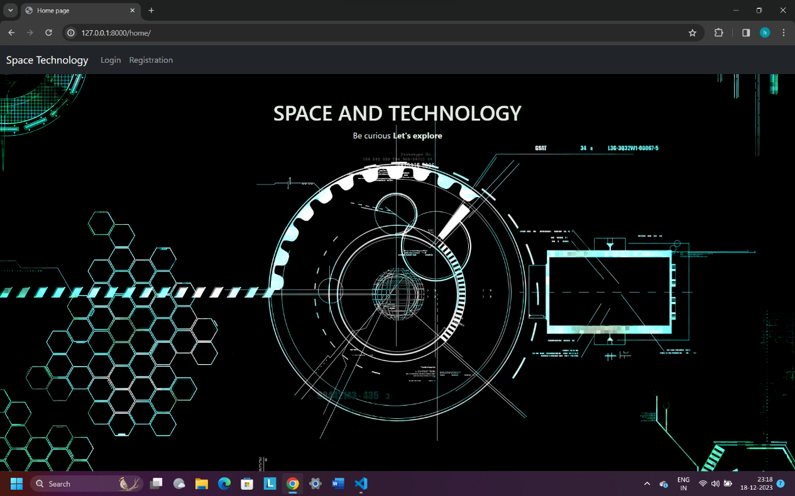

**Description:-** The above screenshot shows us home page where user will be able to do register/login.

**7.2 REGISTER PAGE**

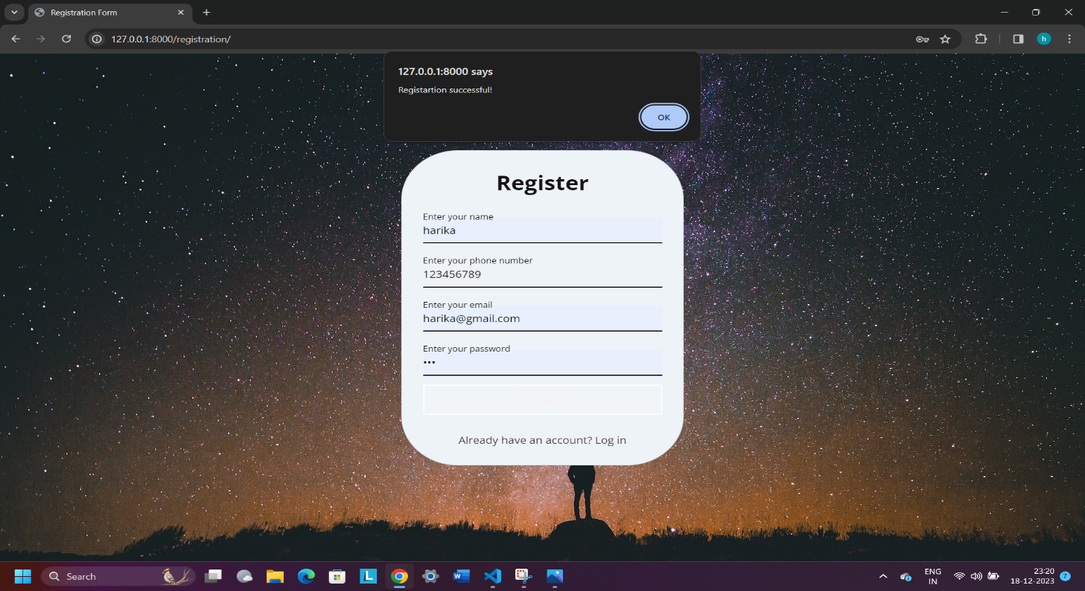

**Description:-** The above screenshot shows us registration page, whenever user did registration it will navigate to the login page.

**7.3 LOGIN PAGE**

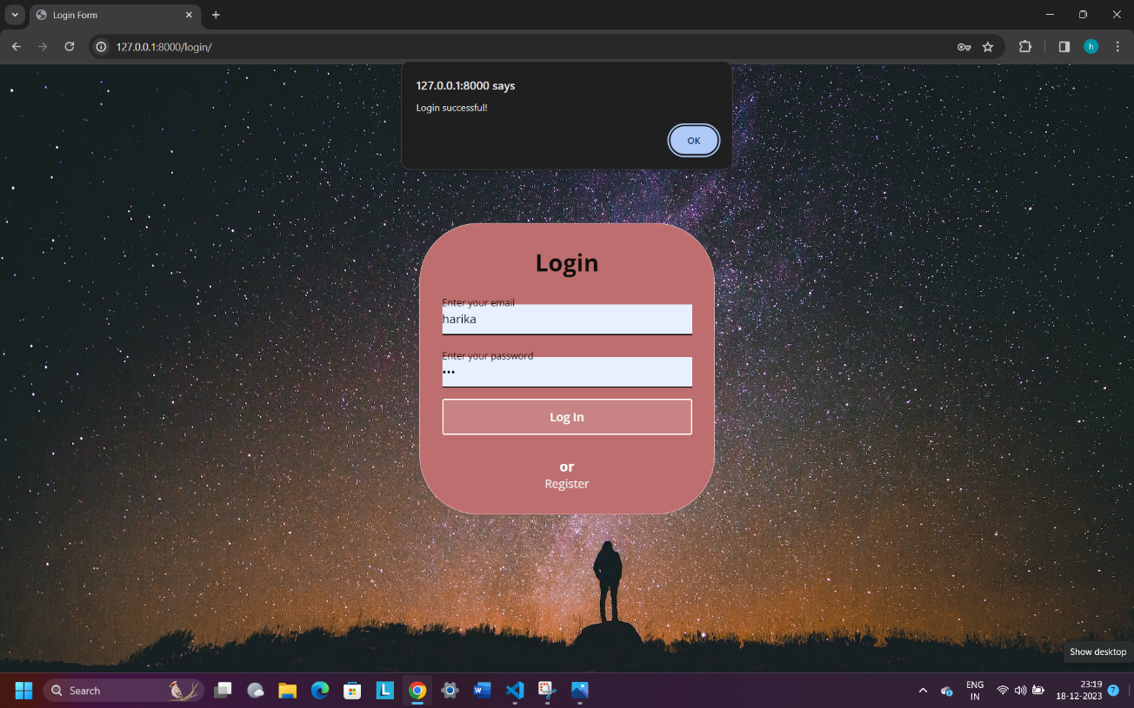

**Description:-** When user registered, they can navigate to the lets_learn page.

**7.4 LETS_LEARN PAGE**

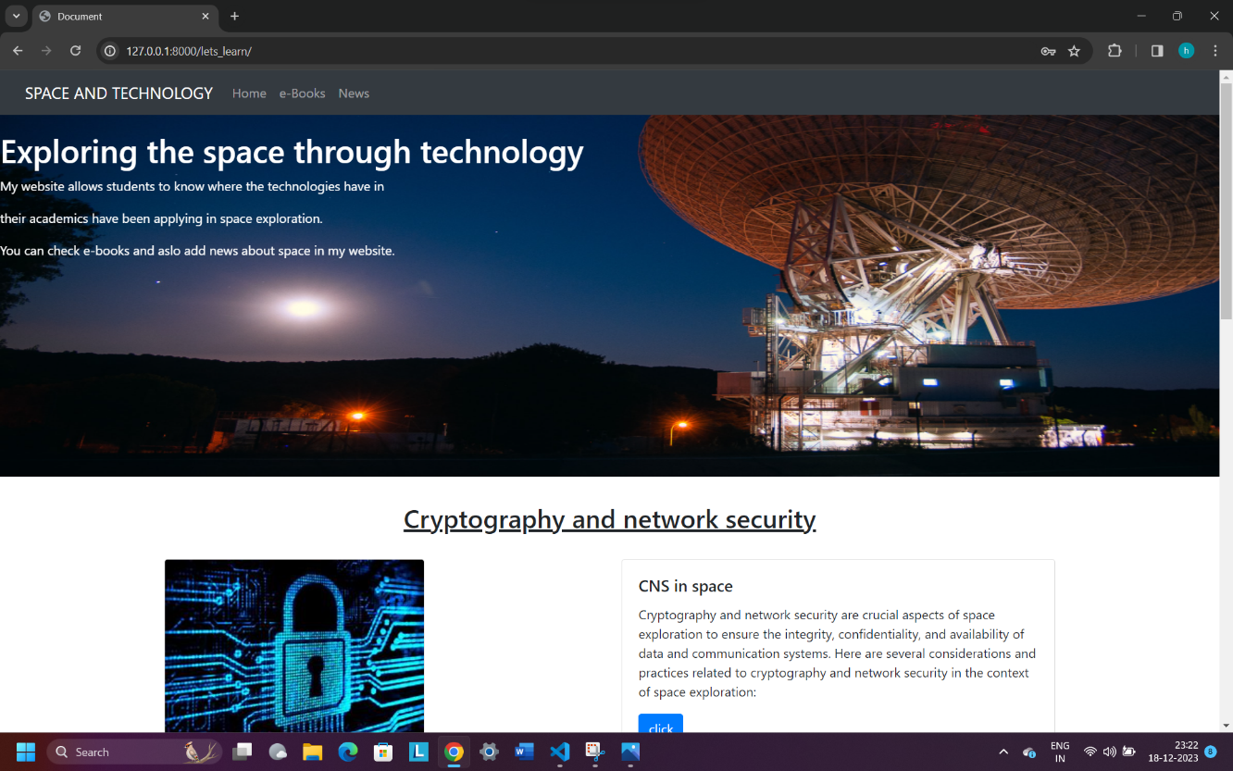

**Description:-** Here we can go to news page and also read book references and also read technology in space exploration applications.

**7.5 NEWS PAGE**

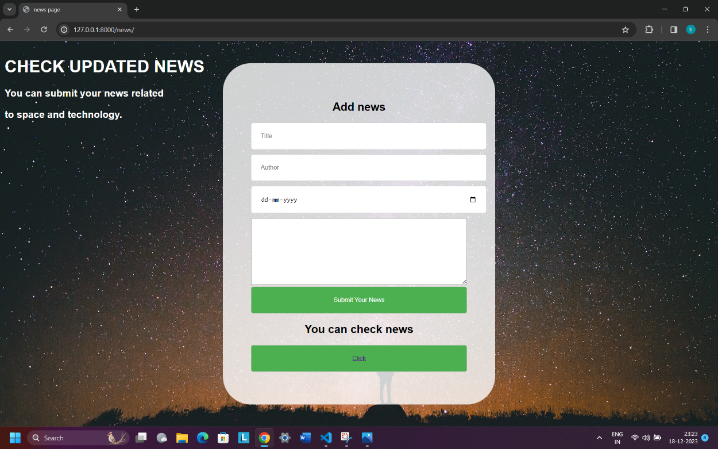

**Description:-** The above screenshot shows news page where, user can add updated news to our website.

**7.6 E_BOOKS PAGE**

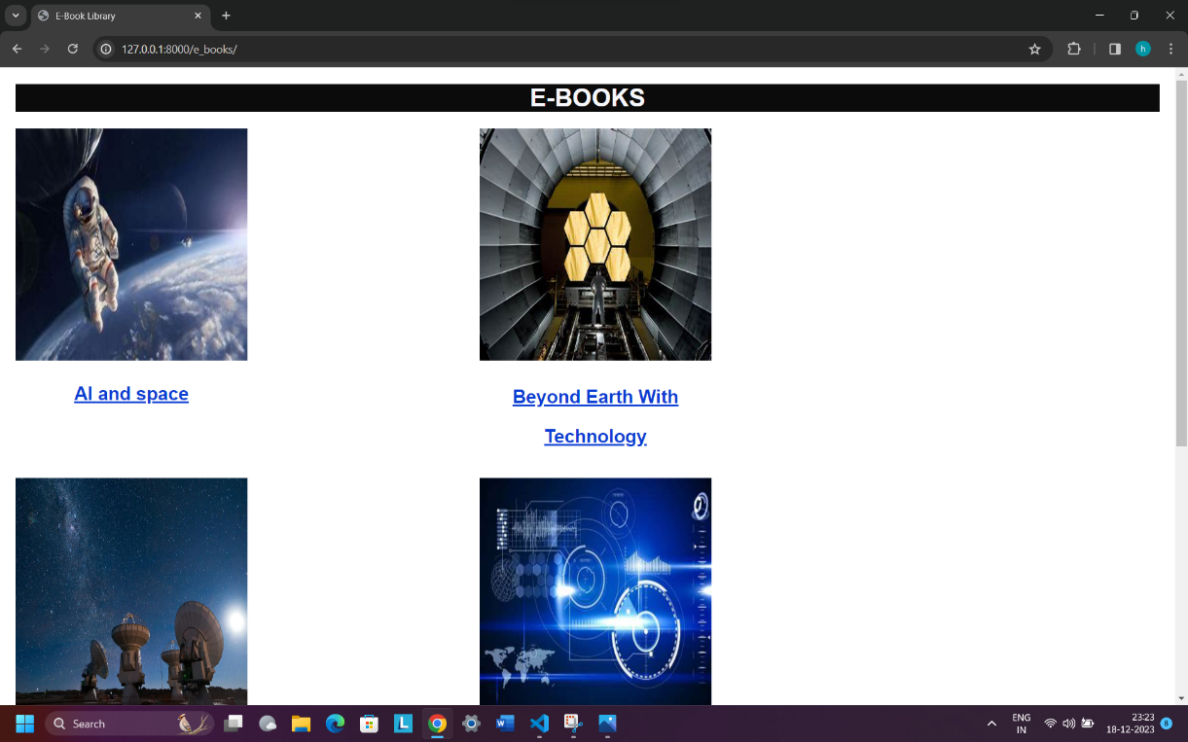

**Description:-** The above screenshot shows us e-books, where user can read reference books.

**CONCLUSION**

**CONCLUSION**

conclusion, the realms of space and technology represent an awe-inspiring frontier that continues to captivate the imagination of humanity. The exploration of space, fueled by technological advancements, has not only expanded our understanding of the cosmos but has also pushed the boundaries of what is achievable. From the early days of space race triumphs to the collaborative international efforts of today, the journey has been marked by innovation, resilience, and the indomitable human spirit.

It can be Technology, as the driving force behind space exploration, has undergone rapid and transformative evolution. It has enabled us to send spacecraft to distant planets, observe the far reaches of the universe, and even set foot on celestial bodies beyond Earth. The convergence of computing power, materials science, and engineering ingenuity has paved the way for breakthroughs that were once considered unimaginable.

Moreover, space exploration has not only deepened our understanding of the cosmos but has also catalyzed advancements with profound implications for life on Earth. Technologies developed for space missions have found applications in diverse fields, from medical imaging and telecommunications to environmental monitoring and resource management.

**BIBLIOGRAPHY**

**TEXT BOOKS :**

1. Fundamentals of Astrodynamics" by Roger R. Bate, Donald D. Mueller, and Jerry E. White
2. Introduction to Space Dynamics" by William Tyrrell Thomson
3. Space Mission Analysis and Design" by James R. Wertz and Wiley J. Larson
4. Satellite Communications" by Timothy Pratt, Charles Bostian, and Jeremy Allnutt

**WEBSITES :**

<https://www.nasa.gov/>

<https://www.khanacademy.org/science/cosmology-and-astronomy>

<https://www.edx.org/>

<https://www.spacex.com/>